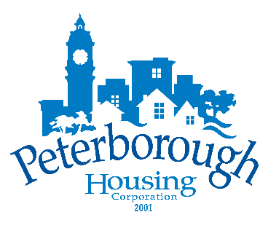

Peterborough Housing Corporation
Board of Directors
Wednesday, June 28th, 2023 – 5:30PM
Hunt Terraces, Meeting Room #112,
555 Bonaccord Street, Peterborough, ON

“We respectfully acknowledge that we are on the
traditional territory of the Mississauga Anishinaabeg.
We offer our gratitude to the First Nations for their care for,
and teachings about, our earth and our relations.
May we honour those teachings.”

Agenda

- Approval of Agenda

- Conflict of Interest

- Delegation

- Confirmation of Minutes
  - Open Session Board Meeting, May 24, 2023

- Operational Reports
- Report 2023-018 – CEO Report
- Report 2023-019 – 2023 Board Tour of Properties – Overview
- Report 2023-020 – 2023 Q1 KPI Report
- Report 2023-021 – 2023 Engagement Survey Results
- Report 2023-022 Strategic Plan, Operational Actions for 2023/24
- Report 2023-023 – 2022 Annual Report

- Committee Reports
  - Finance, Audit & Administrative Committee
    - No report
  - Governance, Human Resources & Strategy Committee
    - No report

- Closed Session
  - Confirmation of Closed Minutes
    - Closed Session Board Meeting, May 24, 2023

- Report of Closed Session

- Adjournment

