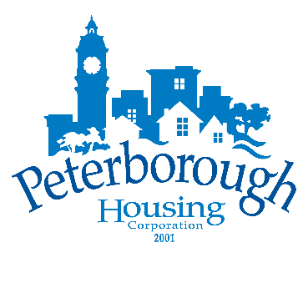

Peterborough Housing Corporation
Board of Directors
Wednesday, May 24th, 2023 – 5:30PM
Hunt Terraces, Meeting Room #112,
555 Bonaccord Street, Peterborough, ON

“We respectfully acknowledge that we are on the
traditional territory of the Mississauga Anishinaabeg.
We offer our gratitude to the First Nations for their care for,
and teachings about, our earth and our relations.
May we honour those teachings.”

Agenda

- Approval of Agenda

- Conflict of Interest

- Delegation

- Confirmation of Minutes
  - Open Session Board Meeting, March 22, 2023

- Operational Reports
- Report 2023-013 – CEO Report

- Financial Reports
  - Report 2023-014 – 2023 Q1 Operating & Capital Results (Jan-Mar)
  - Report 2023-015 – 2023 Q1 Reporting Obligations (as at Mar 31st)

- Committee Reports
  - Finance, Audit & Administrative Committee
    - Report 2023-016 – 2022 Financial Statements & Investment Report
  - Governance, Human Resources & Strategy Committee
    - No report

- Closed Session
  - Confirmation of Closed Minutes
    - Closed Session Board Meeting, March 22, 2023
  - Report 2023-017 – Rent Supplement Program

- Report of Closed Session

- Adjournment

